**THE DATASET**

The Social Network Ads dataset provides insights into the relationship between age distribution and estimated salary through various budget allocations. This dataset comprises 400 data points (rows) and features 3 informative columns: 'Age,' ‘Estimated Salary,’ and 'Purchased.' It offers a comprehensive view of the impact of advertising investments on sales performance. Below are the first 4 rows of the dataset (the 4 rows are picked from 0-3).

|  |  |  |
| --- | --- | --- |
| **Age** | **Estimated Salary** | **Purchased** |
| 19.0 | 19000.0 | 0.0 |
| 35.0 | 20000.0 | 0.0 |
| 26.0 | 43000.0 | 0.0 |
| 27.0 | 57000 | 0.0 |

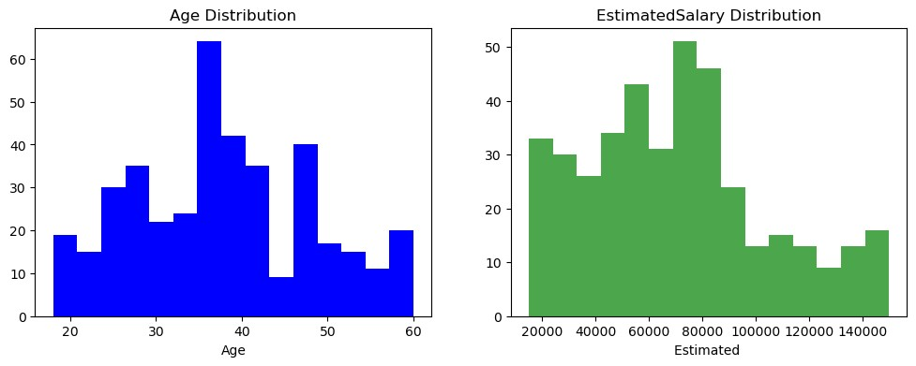

The chart above provides a visualization of the distribution of Social Networking in the Age Distribution alongside its corresponding impact on Estimated Salary Distribution. Notably, the distribution of Age is normally distributed (zero skew). The interquartile range (IQR) of age falls between 30.000000 and 46.000000, the interquartile range (IQR) of estimated salary is 43000.000000, while the interquartile range (IQR) of purchased is 0 and 1. While the Estimated salary distribution exhibits a right-skew pattern, indicating that as we progress from lower to higher levels of salary, the rate of spending on estimated salary tends to decrease.

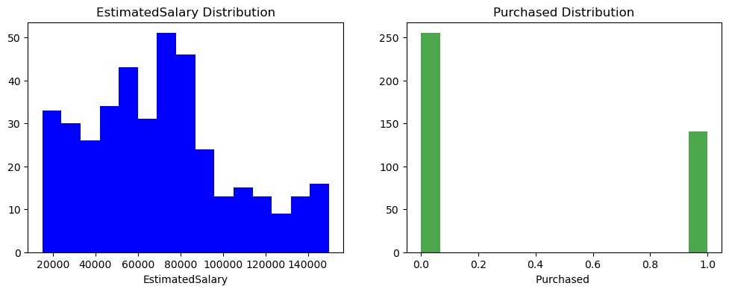

The chart above provides a visual depiction of the distribution of social network, differentiating between estimated salary and purchased. Notable patterns emerge within each medium:

**For Estimated Salary distribution:** The chart illustrates that the highest concentration of estimated salary spending falls within the range of 78000 to 80000 units. This indicates that a significant portion of the data points allocates budget in this higher spending bracket. Conversely, the lowest estimated spending is observed in the vicinity of 130000 units.

**For Purchased:** The chart reveals that the highest concentration falls within the range 0units while the lowest estimated spending is observed in the vicinity of 1.0units.

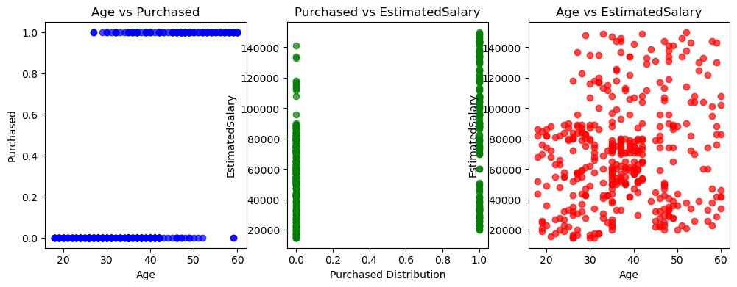

The scatter plots displayed above depict the relationships between Social Network on Age, Purchased, and Estimated Salary and their respective impacts on distribution.

Age distribution vs. Purchased shows the binary number of 0 and 1:

At 0, it showed the ages from 10-53 did not made the highest purchased; age 54-59 did not make any purchase.

At 1, it showed that people in the ages of 10 to 25 did not make any purchase at all. At age 50 to 60, the purchased became massive.

Purchased vs. Estimated salary shows that people that made purchase in the estimated salary range of 120000-140000 while people who did not make much purchased are in the estimated salary range of 95000 and 140000.

Age vs. estimated salary distribution shows a weaker and less consistent linear relationship with sales, indicating their impact varies.

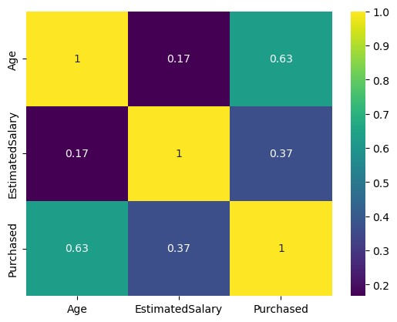s

The above chat shows correlations between different variables (Age, Estimated Salary and Purchased). Age and Purchased have a strong positive correlation of approximately 0.630, this indicates that as the Age distribution increases, estimated salary also tend to increase significantly. Estimated Salary and Purchased have a moderate positive correlation of around 0.370, suggesting that there is a moderate positive relationship between Estimated Salary and Purchased. An increase in Estimated Salary is associated with a moderate increase in Purchased. Age and Estimated Salary also exhibit a very weak positive correlation of around 0.170, indicating a minimal relationship between Age and Estimated Salary budgets.

**SUMMARY**

In conclusion, this dataset provides valuable insights into the impact of Social network on sales across distributions. Age distribution shows the strongest correlation with Purchased, followed by estimated Salary, while age distribution and estimated Salary has the weakest correlation. The reports shows 3 explanatory analysis which included the univariate, bi-variate and multi-variate. The Age distribution vs. Purchased has a binary number of 0 and 1.These findings can guide Social Network strategies and age distribution for budget allocation